Gaming-Bets

Version 1.0

Revision History

|  |  |  |  |
| --- | --- | --- | --- |
| **Date** | **Version** | **Description** | **Author** |
| 06.04.2016 | 1.0 | Basic Information | André Helbig |

Table of Contents

1. Use-Case Name 4

1.1 Brief Description 4

2. Flow of Events 4

2.1 Basic Flow 4

2.2 Alternative Flows 6

2.2.1 Cannot reach server 6

3. Special Requirements 6

4. Preconditions 6

1. App started 6

2. Internet Connection 6

5. Postconditions 6

6. Extension Points 6

7. Function Points 7

# Use-Case Name

## Brief Description

This Use-Case will provide the possibility to buy rewards like new profile pictures to customize the application.

# Flow of Events

## Basic Flow



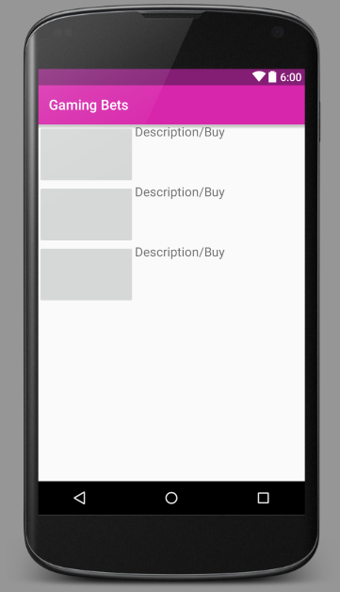

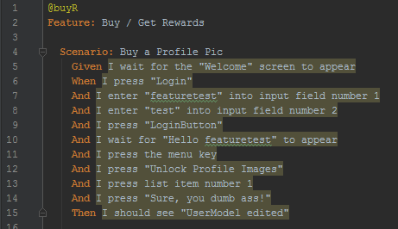

[Link to Code](https://github.com/GamingBets/GamingBets/blob/master/features/11_BuyRewards.feature)

## Alternative Flows

### Cannot reach server

If the application cannot reach the server, the user will be notified if possible via app. He will be asked to try it again later.

# Special Requirements

n/a

# Preconditions

## App started

The app must be running.

## Internet Connection

To buy a reward, an internet connection is necessary.

# Postconditions

n/a

# Extension Points

n/a

# Function Points

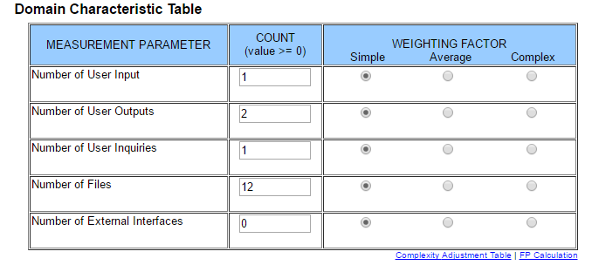

This results in a function point calculation of **63.7**.